§
Lab08: Working with rule and facts.
Example of Rules (I):

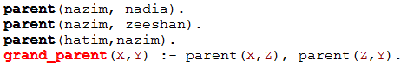
Tasks To Do:
1.Write down the PROLOG Rules for the following sentences:

Declarative Sentences | Prolog Rules
Person1 is sibling of Person2 if Person3 is parent of Person1 and Person3 is parent of Person2. | Sibling(Person1,Person2):-Parent(  Person3,Person1),Parent(Person3,Person2).
Person1 is child of Person2 if Person2 is parent of Person1. | Child(X,Y):-Parent(Y,X),
It will rain today if clouds are heavy and air pressure is low. | RainToday(X,Y):-CloudsHeavy(X),AirPressurelow(Y).

2. Case Study: Family Tree
Consider the following family tree shown in figure below
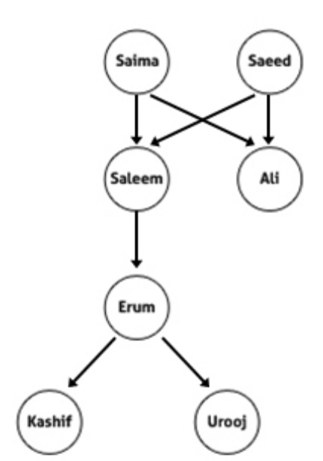
Questions:
Is saleem father of ali?
Is kashif brother of urooj?
Who is father of kashif?
Is erummother of urooj?
Who is grandfather of urooj?
Is salmagrandmother of erum?
Saeed is father of whom?
Salma is mother of whom?
father(saeed,ali).
mother(saima,ali).
father(saeed,saleem).
mother(saima,saleem).
father(saleem,erum).
mother(erum,urooj).
mother(erum,kashif).
brother(saleem,ali).
grandfather(saeed,erum).
grandmother(saima,erum).
brother(kashif,urooj).
sister(urooj,kashif).
grandfather(saleem,kashif).
grandmother(saima,erum).
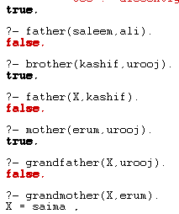
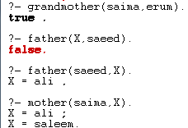
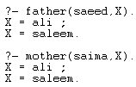
3.Create your family tree using prolog.
SOURCE CODE: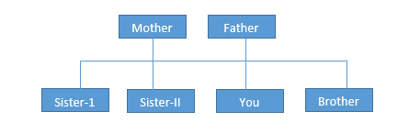
mother(ruby,rabia).
father(bashir,rabia).
mother(ruby,ayesha).
father(bashir,ayesha).
mother(ruby,bilal).
father(bashir,bilal).
mother(ruby,hafsa).
father(bashir,hafsa).
mother(ruby,mariyum).
father(bashir,mariyum).
male(bilal).
female(rabia).
female(ayesha).
female(hafsa).
female(mariyum).

parent(X,Y):-mother(X,Y);father(X,Y).
child(X,Y):-parent(Y,X).
brother(X,Y):-male(X),male(Y),parent(Z,X),parent(Z,Y).
sister(X,Y):-female(X),female(Y),parent(Z,X),parent(Z,Y).

OUTPUT:
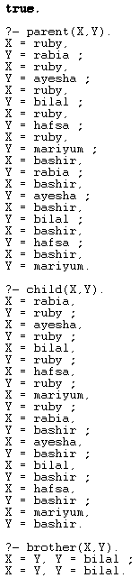
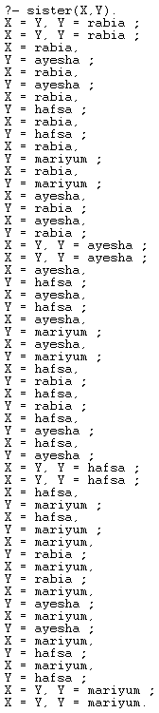
4.The following picture shows who is sitting at the lunch table.
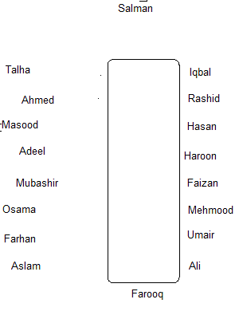
Define the predicate sits_right_of to represent who is sitting right of whom.sits_right_of(X,Y) should be true if X is to the right of Y.
Based on this knowledge base, formulate the rules defining the following predicates:
(i) left_of: sits_left_of(X,Y) should be true if X is to the left of Y.
(ii) are_neighbors_of: are_neighbors_of(X,Y,Z) should be true if X is to the left of Y and Z is to the right of Y.
(iii) next_to_each_other: next_to_each_other(X,Y) should be true if X is next to Y.
Test your implementation by asking queries. For example:
- Is Osama to the right of Farhan?
- Is Osama to the right of Mubashir?
- Who is to the right of Umair?
- Who is sitting at the table?
- Who is sitting between Mubashir and Masood?

SOURCE CODE:
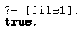
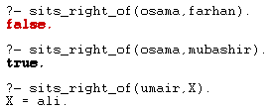
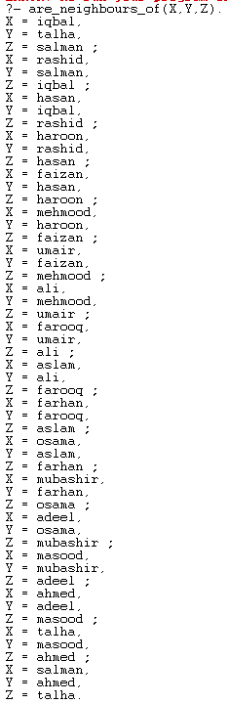
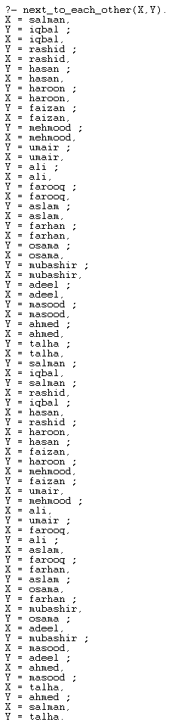
5. Selection criteria using rules.
- starter(soup).
- starter(salad).
- main_course(rice).
- main_course(pizza).
- main_course(burger).
- desert(custard).
- desert(ice_cream).
Task To do:
- Create rules for hungry, very_hungry and on_diet.
- For hungry only starter and main course, for very_hungry starter, main course and desert, for on_diet it displays only starters.
SOURCE CODE:
starter(soup).
starter(salad).
main_course(rice).
main_course(pizza).
main_course(burger).
desert(custard).
desert(ice_cream).
hungry(X,Y):-starter(X),main_course(Y).
very_hungry(X,Y,Z):-starter(X),main_course(Y),desert(Z).
on_diet(X):-starter(X).

OUTPUT:
